Complexities

Our basic goal of running the program is develop the software that is capable of running the code in limited resources available.  
1. Assumption that hardware is not optimised enough for the code

2. Data may increase with the time

Time and Space complexity:

It is what we can consider as the time taken to execute the particular code, let's take an example where we try to find a particular element in the list. Although the size of the list increases it falls back when it is not more performable for the environment.

Linear search *(I hope if this workshop work goes great then we will study ahead)*

func f(ienumerable, size , element){

for i from 0 to ienumerable[size]{

if (i == element){

return i

}

}

else:{

return -1

}

}

Here, if we look one loop is executed that makes as the size of the ienumerable increases the time of execution increases so it is dependent upon **(n as size)**.

Binary search

func f(ienumerable, left, right, element){

while left <= r{

middle_idx = left + (right - left) // 2

if (ienumerable[middle_idx] == element){

return middle_idx

}

elseif (ienumerable[middle_idx] < element){

left = middle_idx + 1

}

elseif (ienumerable[middle_idx] > element){

right = middle_idx - 1

}

else:{

return -1

}

}

Here, if we look one loop is executed that makes as the size of the ienumerable is cut into half or the middle of the ienumerable so it is dependent upon **(log(n as size))**.

Hash/Dictionary:

The retrieval of an ienumerable is very easy, just ask the index of the label which holds the values that is one line code. That makes the code **(1)** run time in respect to the size.

Every code has its known complexity and method to write but again less time takes more of the complex code to write as we see from **n → logn → 1**. Though the time taken by the code decreases with the increase in the complexity of writing code.

I usually believe space complexity is something which depends upon the hardware as data always varies with inputs, which is uncontrollable for the programmer.

From above we can conclude that no:of steps and the time of execution always vary with the hardware and the inputs on the user.   
So what should be the ideal way of doing it → we should make it as the function of the rate of growth.

Rate of growth:

The execution time increases as function input increases. But still it depends upon the higher value. For example: Let's say we bought 1kg of onion, so we always expect the seller to give 5gram of coriander for free. So, our actual vegetable weight is 1.005kg. But still we consider it 1kg as the weight of onion is much more than the weight of coriander.

For example: - function ⇒ f(x2 + 4x ≈ x2) ⇒ because x2 is the input which can change the program execution time.

*Plag ayaga image main kyuki net se hain*

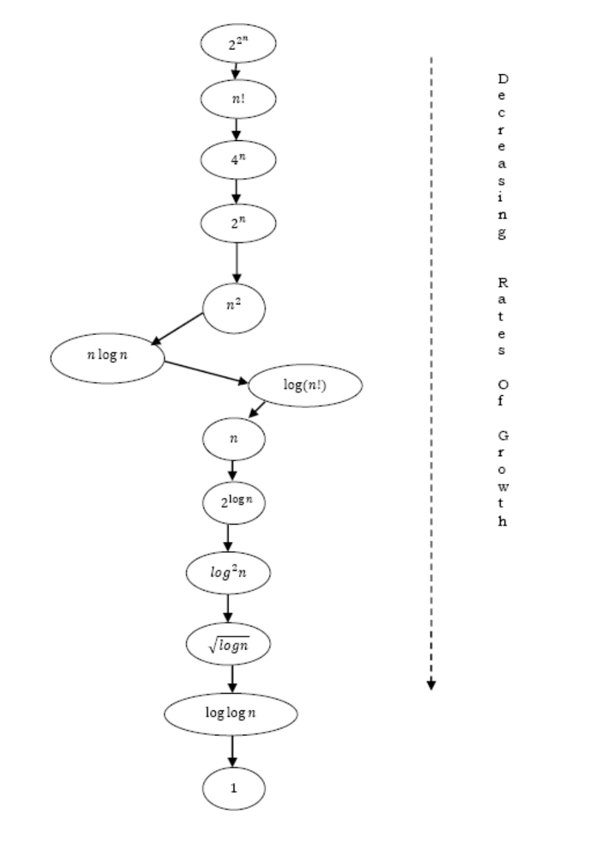

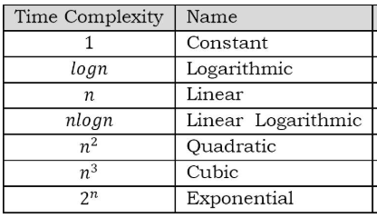

Asymptotic Analyser

